
Company
Logotype

Cone Beam Computed Tomography- Report



Porur Dental X-rays & CBCT

Patient Name : Mr. John Beritto | Date of Report : 31.05.2024
Age/ Gender : 62 years/ Male | Region of Interest : CBCT Full Skull
Referring doctor: Dr. Alan Jeshwanth | Indication : Implant assessment- all on 4
Clinical Notes: Nil
PATIENT INFORMATION

CBCT- Maxilla provided
CBCT – IMAGE DETAILS

RADIOGRAPHIC INTERPRETATION

- Presence of hyperdense crown structures in relation to 11, 12,13, 14, 15, 16, 17, 21, 22, 23, 24, 25, 26, 27.
- The alveolar ridge in relation to the maxillary alveolar ridge is present with normal trabecular pattern.
- The left maxillary sinus is present with complete hyperdense opacification.
- The right maxillary sinus is present with mucosal thickening and discontinuity in relation to its floor in 17 region.

IMPLANT ASSESSMENT

 | 11, 12, 13 region | 21, 22, 23 region
Sub-Crestal | 6.79 | 6.08
Mid- Crestal | 7.56 | 6.16
Distance between the alveolar ridge and Floor of the Nasal cavity (in mm) | 14.05 | 14.88

 | 14, 15 region | 16, 17 region | 24, 25 region | 26, 27 region
Sub-Crestal (in mm) | 9.11 | - | 7.3 | -
Mid- Crestal (in mm) | - | - | 8.26 | -
Distance between the alveolar ridge and floor of the maxillary sinus (in mm) | 6.24 | 1.82 | 8.99 | 1.49

RADIOGRAPHIC IMPRESSION

- Crowns in relation to maxillary arch.
- Bilateral Maxillary sinusitis.
- Oro antral communication- right maxillary sinus.

Kindly correlate with clinical findings


IMAGES FOR REFERENCE

RECONSTRUCTED PANORAMIC VIEW

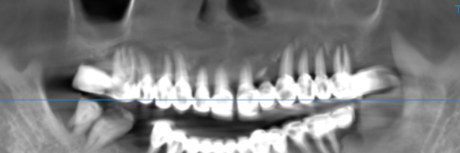
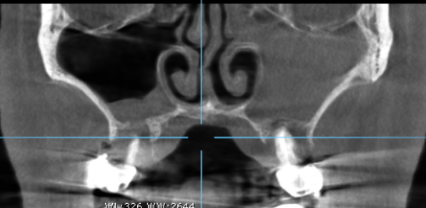
Discontinuity in relation to the floor of the right maxillary sinus
Completely opacified left maxillary sinus

3-DIMENSIONAL VIEW

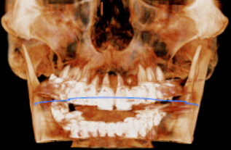

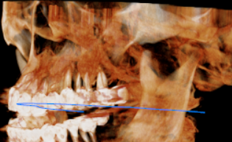

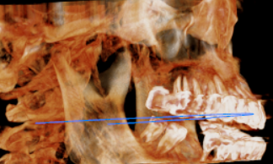

CROSS SECTIONAL VIEW

11, 12, 13 region | 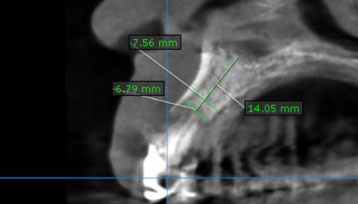
14, 15 region | 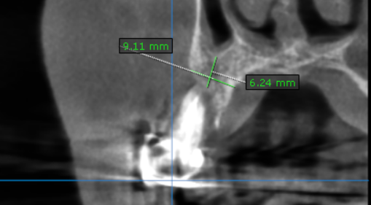
16, 17 region | 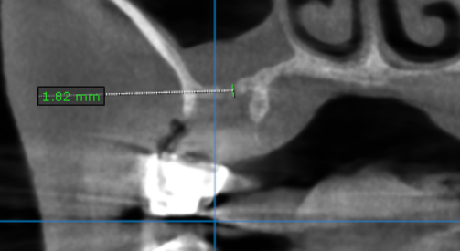
21, 22, 23 region | 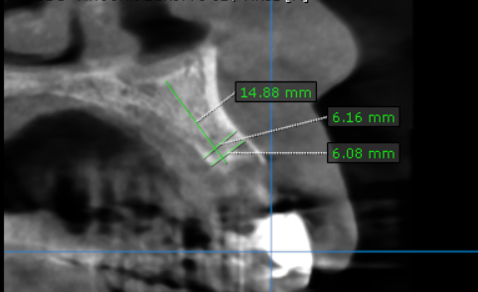
24, 25 region | 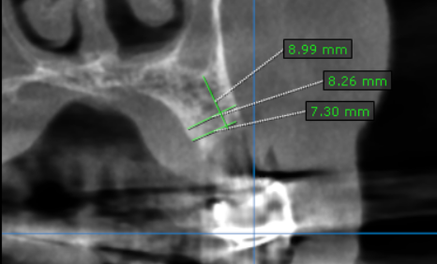
26, 27 region | 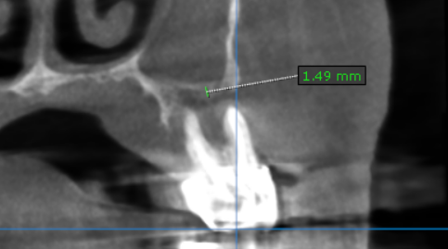

**** End of report ****

